Title for paper Submitted to the Academic Journal of Engineering Applications

First Author¹, Second Author²
¹ Email address, Qualifications, Country
² Email address, Qualifications, Country

Abstract- These instructions give you guidelines for preparing papers for AJEA Journal. Use this document as a template or as an instruction set. The electronic file of your paper will be formatted further at AJEA. Paper titles should be written in uppercase and lowercase letters, not all uppercase. Full names of authors are preferred in the author field, but are not required. Put a space between authors’ initials. The abstract must be a concise yet comprehensive reflection of what is in your article. In particular, the abstract must be self-contained, without abbreviations, footnotes, or references. It should be a microcosm of the full article. The abstract must be between 150–250 words. Be sure that you adhere to these limits; otherwise, you will need to edit your abstract accordingly. The abstract must be written as one paragraph, and should not contain displayed mathematical equations or tabular materials. The abstract should include three or four different keywords or phrases, as this will help readers to find it. It is important to avoid over-repetition of such phrases as this can result in a page being rejected by search engines. Ensure that your abstract reads well and is grammatically correct.

Keywords - About four key words or phrases in alphabetical order, separated by commas. Keywords are used to retrieve documents in an information system such as an online journal or a search engine. (Mention 3-5 keywords)
- Introduction
This article guides a stepwise walkthrough by Experts for writing a successful journal or a research paper starting from inception of ideas till their publications. Research papers are highly recognized in scholar fraternity. Research scholars publish their research work in leading journals to complete their grades. In addition, the published research work also provides a big weight-age to get admissions in reputed varsity. Now, here we enlist the proven steps to publish the research paper in a journal.
Identify the constructs of a Journal – Essentially a journal consists of five major sections. The number of pages may vary depending upon the topic of research work but generally comprises of 5 to 15 pages. These major sections are: Abstract, Introduction, Research Methodology, Results or Finding and Conclusions.
- Guidelines for article preparation
When you open the WORD Template, select “Page Layout” from the “View” menu in the menu bar (View | Page Layout). Some versions may have different ways to access the same functionalities noted here). Then, type over sections of the Template or cut and paste from another document and use markup styles. Highlight a section that you want to designate with a certain style, and then select the appropriate name on the style menu. The style will adjust your fonts and line spacing. Do not change the font sizes or line spacing to squeeze more text into a limited number of pages. Use italics for emphasis; do not underline. To insert images in Word, position the cursor at the insertion point and either use Insert | Picture From File or copy the image to the Windows clipboard and then Edit | Paste Special | Picture (with “float over text” unchecked).

Abbreviations and Acronyms
Define abbreviations and acronyms the first time they are used in the text, even after they have already been defined in the abstract. Abbreviations such as AJEA, SI, ac, and dc do not have to be defined. Abbreviations that incorporate periods should not have spaces: write “C.N.R.S.,” not “C. N. R. S.” Do not use abbreviations in the title unless they are unavoidable (for example, “AJEA” in the title of this article).

Some Recommendations
Use one space after periods and colons. Hyphenate complex modifiers: “zero-field-cooled magnetization.” Avoid dangling participles, such as, “Using Eq. (1), the potential was calculated.” [It is not clear who or what used Eq. (1).] Write instead, “The potential was calculated by using Eq. (1),” or “Using Eq. (1), we calculated the potential.”
Use a zero before decimal points: “0.25,” not “.25.” Use “cm³,” not “cc.” Indicate sample dimensions as “0.1 cm × 0.2 cm,” not “0.1 × 0.2 cm².” The abbreviation for “seconds” is “s,” not “sec.” Use “Wb/m²” or “webers per square meter,” not “webers/m².” When expressing a range of values, write “7 to 9” or “7-9,” not “7~9.”
A parenthetical statement at the end of a sentence is punctuated outside of the closing parenthesis (like this). (A parenthetical sentence is punctuated within the parentheses.) In American English, periods and commas are within quotation marks, like “this period.” Other punctuation is “outside”! Avoid contractions; for example, write “do not” instead of “don’t.” The serial comma is preferred: “A, B, and C” instead of “A, B and C.”
If you wish, you may write in the first person singular or plural and use the active voice (“I observed that ...” or “We observed that ...” instead of “It was observed that ...”). Remember to check spelling. If your native language is not English, please get a native English-speaking colleague to carefully proofread your paper.

Equations and Unites
If you are using Word, use either the Microsoft Equation Editor for equations in your paper (Insert | Object | Create New | Microsoft Equation or MathType Equation). “Float over text” should not be selected.
Number equations consecutively with equation numbers in parentheses flush with the right margin, as in Eq. (1). First use the equation editor to create the equation. Then select the “Equation” markup style. Press the tab key and write the equation number in parentheses. Use parentheses to avoid ambiguities in denominators. Punctuate equations when they are part of a sentence, as in
 | $$x=\frac{-b±\sqrt{b^{2}-4ac}}{2a}$$ | (1)

Be sure that the symbols in your equation have been defined before the equation appears or immediately following. Italicize symbols (T might refer to temperature, but T is the unit tesla). Refer to “Eq. (1),” not “ (1)” or “equation (1),” except at the beginning of a sentence: “Equation (1) is ... .”
Use either SI (MKS) or CGS as primary units. (SI units are strongly encouraged.) English units may be used as secondary units (in parentheses). This applies to papers in data storage. For example, write “15 Gb/cm² (100 Gb/in²).” Avoid combining SI and CGS units, such as current in amperes and magnetic field in oersteds. This often leads to confusion because equations do not balance dimensionally. If you must use mixed units, clearly state the units for each quantity in an equation.
The SI unit for magnetic field strength H is A/m. However, if you wish to use units of T, either refer to magnetic flux density B or magnetic field strength symbolized as µ₀H. Use the center dot to separate compound units, e.g., “A·m².”
- some common mistakes
Here comes the most crucial step for your research publication. Ensure the drafted journal is critically reviewed by your peers or any subject matter experts. Always try to get maximum review comments even if you are well confident about your paper.
The word “data” is plural, not singular. The subscript for the permeability of vacuum µ₀ is zero, not a lowercase letter “o.” The term for residual magnetization is “remanence”; the adjective is “remanent”; do not write “remnance” or “remnant.” Use the word “micrometer” instead of “micron.” A graph within a graph is an “inset,” not an “insert.” The word “alternatively” is preferred to the word “alternately” (unless you really mean something that alternates). Use the word “whereas” instead of “while” (unless you are referring to simultaneous events). Do not use the word “essentially” to mean “approximately” or “effectively.” Do not use the word “issue” as a euphemism for “problem.”
Be aware of the different meanings of the homophones “affect” (usually a verb) and “effect” (usually a noun), “complement” and “compliment,” “discreet” and “discrete,” “principal” (e.g., “principal investigator”) and “principle” (e.g., “principle of measurement”). Do not confuse “imply” and “infer.” Prefixes such as “non,” “sub,” “micro,” “multi,” and “ultra” are not independent words; they should be joined to the words they modify, usually without a hyphen. There is no period after the “et” in the Latin abbreviation “et al.” (it is also italicized). The abbreviation “i.e.,” means “that is,” and the abbreviation “e.g.,” means “for example” (these abbreviations are not italicized).
- Guide lines for tables and figures
Tables should be numbered with Roman numerals followed by a colon (:). Table headings should be placed above tables and center justified. Leave one line space between the heading and the table body. Table I lists the detail font formats of the paper.
Table I: The font the spacing styles for AJEA submission
2.5 cm |  | Page Top and Bottom Margins
2.0 cm |  | Page Left and Right Margins
Single space |  | Line Spacing (Spaces)
Times New Roman |  | All Font Styles
0.35 cm |  | New Paragraph First Line Indentation
Font (Size - Format - Alignment)
Alignment | Format |  | Size
center | bold |  | 22 | Paper Title
center | bold |  | 12 | Author/s
center | normal |  | 10 | Email address
left-justified | bold |  | 11 | Abstract
justified | normal |  | 10 | Text
center | capitalized-bold |  | 11 | Sections
left-justified | italic |  | 11 | Subsections
left-justified | italic |  | 10 | Sub-subsections
center | normal |  | 10 | Equations
center | italic |  | 9 | Table title
center | italic |  | 9 | Figure caption
justified | normal |  | 9 | References
Figures and tables must be centred in the page. Large figures and tables may span in multiple page. Graphics may be full colour. Graphics must not use stipple fill patterns because they may not be reproduced properly. Please use only solid fill colours which contrast well both on screen and on a black-and-white hardcopy.
Figure axis labels are often a source of confusion. Use words rather than symbols. Write the quantity “Magnetization,” or “Magnetization M,” not just “M.” Put units in parentheses. Do not label axes only with units. As in Figure 1, for example, write “Magnetization (A/m)” or “Magnetization (Am⁻¹),” not just “A/m.” Do not label axes with a ratio of quantities and units. For example, write “Temperature (K),” not “Temperature/K.”
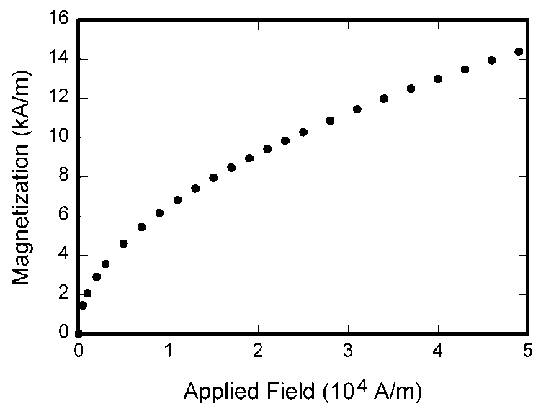

Figure 1 Magnetization as a function of applied field. Note that “Figure” is bold and not abbreviated. There is a period after the figure number, followed by two spaces. It is good practice to explain the significance of the figure in the caption.

Multipliers in figure labels can be especially confusing. Write “Magnetization (kA/m)” or “Magnetization (10³ A/m).” Do not write “Magnetization (A/m) × 1000” because the reader would not know whether the top axis label in Figure 1 meant 16000 A/m or 0.016 A/m. Figure labels should be legible, approximately 8 to 10 point type.
Figures must be numbered using Arabic numerals. Figure captions must be in 9 point normal font. Captions of a single line must be cantered whereas multi-line captions must be justified. Captions with figure numbers must be placed after their associated figures.
- Conclusion
A conclusion section is required. A conclusion may review the main points of the paper, do not replicate the abstract as the conclusion. A conclusion might elaborate on the importance of the work or suggest applications and extensions. Clearly indicate advantages, limitations and possible applications of the study. Special importance is given to the representation of the conclusions. Articles must go beyond telling about a research process and its methodology and provide an analysis of the findings.

Appendix
Appendixes, if needed, appear before the acknowledgment.

Acknowledgment
The preferred spelling of the word “acknowledgment” in American English is without an “e” after the “g.” Use the singular heading even if you have many acknowledgments.

References
The heading of the Appendix, Acknowledgment and References sections must not be numbered. All reference items must be in 9 point font. Number the reference items consecutively in square brackets (e.g. [1]).
When referring to a reference item, please simply use the reference number, as in [2]. Do not use “Ref. [3]” or “Reference [3]” except at the beginning of a sentence, e.g. “Reference [3] shows …”. Multiple references are each numbered with separate brackets (e.g. [2], [3], [4]–[6]).
Examples of reference items of different categories shown in the References list include:
- example of a book in [1]
- example of a book in a series in [2]
- example of a journal article in [3]
- example of a conference paper in [4]
- example of a patent in [5]
- example of a website in [6]
- example of a web page in [7]
- example of a databook as a manual in [8]
- example of a datasheet in [9]
- S. M. Metev and V. P. Veiko, Laser Assisted Microtechnology, 2nd ed., R. M. Osgood, Jr., Ed. Berlin, Germany: Springer-Verlag, 1998.
- J. Breckling, Ed., The Analysis of Directional Time Series: Applications to Wind Speed and Direction, ser. Lecture Notes in Statistics. Berlin, Germany: Springer, 1989, vol. 61.
- S. Zhang, C. Zhu, J. K. O. Sin, and P. K. T. Mok, “A novel ultrathin elevated channel low-temperature poly-Si TFT,” IEEE Electron Device Lett., vol. 20, pp. 569–571, Nov. 1999.
- M. Wegmuller, J. P. von der Weid, P. Oberson, and N. Gisin, “High resolution fiber distributed measurements with coherent OFDR,” in Proc. ECOC’00, 2000, pp. 109.
- R. E. Sorace, V. S. Reinhardt, and S. A. Vaughn, “High-speed digital-to-RF converter,” U.S. Patent 5 668 842, Sep. 16, 1997.
- (2002) The IEEE website. [Online]. Available: http://www.ieee.org/
- M. Shell. (2002) IEEEtran homepage on CTAN. [Online]. Available
http://www.ctan.org/tex-archive/macros/latex/contrib/supported/IEEEtran/
- FLEXChip Signal Processor (MC68175/D), Motorola, 1996.
- “PDCA12-70 data sheet,” Opto Speed SA, Mezzovico, Switzerland.

